

“Load Forecasting using Deep Neural Networks”

A review of the major aspects

Gregory Ollivierre | COMP6940 | 27-04-2018

**Research Question**

Machine learning has made an impact on almost every facet of life from driverless cars to CT scans. This paper sought to investigate how an aspect of Machine Learning referred to as Neural networks can be applied to time series forecasting of energy consumption. Energy consumption is seldom ever a static occurrence in a household. Many factors affect when a household decides to use a particular device that is powered by electricity, some of which are wealth and number of people. On aggregate therefore, groups of households will have different energy requirements and the ability to predict this need can help electricity providers do this more efficiently.

**Topic Summary**

Traditional means of forecasting have built on statistical theory to use past information to estimate current or future state. Fundamentally they fall into a class of functions of the form:



Where Yhat is the forecasted variable at time t+1 as a function of past information (Y) for times <= t. These functions can be linear or non linear, and the most popular types that were examined in this paper were based on moving averages (WMA) and Regression (MLR,SVR etc.)

The more modern class of forecasting that has a lot of research being devoted to it is Neural networks. The most basic of these is the Multilayer Perceptron (MLP) or so called “vanilla” feed-forward neural network. It uses a number of networked nodes(neurons), each with a non-linear activation function (usually sigmoid), and a supervised learning technique called backpropagation to predict current or future states. It does not normally include the functionality for looping between layers, or having much depth to the network. The more advanced networks, the so called “Deep” Neural networks include the ability to pass information between layers in both directions and tend to have more layers.

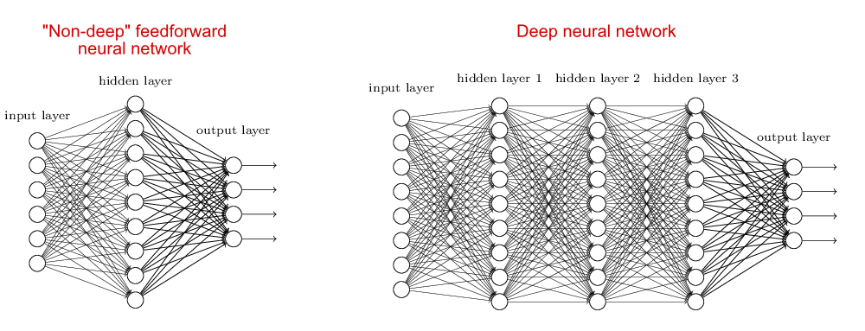

This paper compared the performance of two (2) classes of these Deep Neural networks to the problem of forecasting energy consumption, specifically the Stacked Autoencoder and Recurrent Neural Network(RNN). Autoencoders are very similar to MLP’s but the output and input have the same number of nodes giving it the ability reconstruct the input rather than just predict some value.

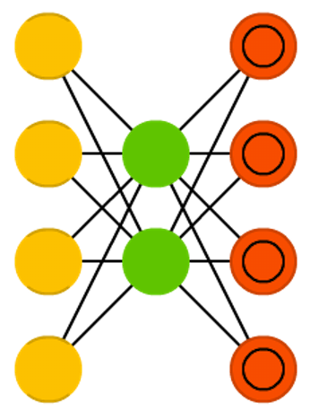 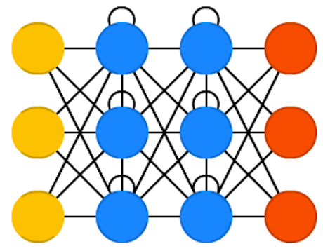

Figure 1: Autoencoder Recurrent Neural Network 1

   

RNN’s are also similar to the general class of Feed Forward networks but an important distinction is their ability to use information from previous pass of the current node.

**Results**

Using a subset of an energy consumption dataset for the analysis, the efficacy of the various techniques was assessed using 2 major metrics. Mean Absolute Percentage error (MAPE) for evaluating whether a particular technique was better than another and Mean Percentage Error (MPE) to evaluate how good that particular technique was at predicting.

Interestingly, Deep Neural networks with and without Autoencoders outperformed RNN’s in both robustness and overall error. The number of allowed epochs for training also played an important part of the assessment because a shorter runtime is desired in STLF.

**References**

<http://www.asimovinstitute.org/neural-network-zoo/>

<https://deeplearning4j.org/lstm>

<http://www.wildml.com/2015/09/recurrent-neural-networks-tutorial-part-1-introduction-to-rnns/>